BANK LOAN SQL QUERIES

--Total Applications
SELECT COUNT (id) AS Total_applications FROM bank_loan_data
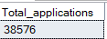
--Total Applications MTD
SELECT COUNT (id) AS MTD_Total_Loan_Applications FROM bank_loan_data
WHERE MONTH(issue_date) = 12 AND YEAR(issue_date) = 2021
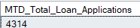
--Total Loan Applications PMDT
SELECT COUNT (id) AS PMTD_Total_Loan_Applications FROM bank_loan_data
WHERE MONTH(issue_date) = 11 AND YEAR(issue_date) = 2021
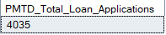
--Total Funded Amount
SELECT SUM(loan_amount) AS Total_Funded_Amount FROM bank_loan_data
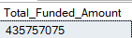
--Total Funded Amount MTD
SELECT SUM(loan_amount) AS MTD_Total_Funded_Amount FROM bank_loan_data
WHERE MONTH(issue_date) = 12 AND YEAR(issue_date) = 2021
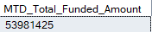
--Previous MTD Total Funded Amount
SELECT SUM(loan_amount) AS PMTD_Total_Funded_Amount FROM bank_loan_data
WHERE MONTH(issue_date) = 11 AND YEAR(issue_date) = 2021
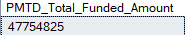
--Total Payment Recieved
SELECT SUM(total_payment) AS Total_Payment_Recieved FROM bank_loan_data
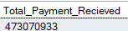
--Total Total Payment Recieved Amount MTD
SELECT SUM(total_payment) AS MTD_Total_Payment_Recieved FROM bank_loan_data
WHERE MONTH(issue_date) = 12 AND YEAR(issue_date) = 2021
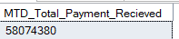
--Previous MTD Total Funded Amount
SELECT SUM(total_payment) AS PMTD_Total_Payment_Recieved FROM bank_loan_data
WHERE MONTH(issue_date) = 11 AND YEAR(issue_date) = 2021
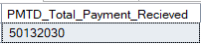
--Average Interest Rate
SELECT ROUND(AVG(int_rate)* 100,2) AS Avg_interest_rate FROM bank_loan_data
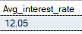
--Average interest rate MTD
SELECT ROUND(AVG(int_rate)* 100,2) AS MTD_Avg_interest_rate FROM bank_loan_data
WHERE MONTH(issue_date) = 12 AND YEAR(issue_date) = 2021
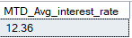
--Average Interest Rate PMTD
SELECT ROUND(AVG(int_rate)* 100,2) AS PMTD_Avg_interest_rate FROM bank_loan_data
WHERE MONTH(issue_date) = 11 AND YEAR(issue_date) = 2021
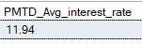
--Debt to Income Ratio
SELECT ROUND(AVG(dti) * 100,2) AS Avg_DTI FROM bank_loan_data
WHERE MONTH(issue_date) = 12 AND YEAR(issue_date) = 2021
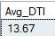
--Debt to Income Ratio MTD
SELECT ROUND(AVG(dti) * 100,2) AS MTD_Avg_DTI FROM bank_loan_data
WHERE MONTH(issue_date) = 12 AND YEAR(issue_date) = 2021
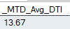
--Debt to Income Ratio PMTD
SELECT ROUND(AVG(dti) * 100,2) AS PMTD_Avg_DTI FROM bank_loan_data
WHERE MONTH(issue_date) = 11 AND YEAR(issue_date) = 2021
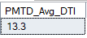
--Good Loan application percentage
SELECT
(COUNT (CASE WHEN loan_status = 'Fully Paid' OR loan_status = 'Current' THEN id END)* 100)
/
COUNT(id) AS Good_loan_percentage
FROM bank_loan_data
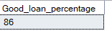

--Good Loan Applications
SELECT COUNT(id) AS Good_Loan_Application
FROM bank_loan_data
WHERE loan_status = 'Fully Paid' OR loan_status = 'Current'
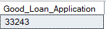
--Good Loan Funded Amount
SELECT SUM(loan_amount) AS Good_Loan_Funded_Amount
FROM bank_loan_data
WHERE loan_status = 'Fully Paid' OR loan_status = 'Current'
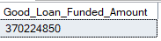
SELECT SUM(total_payment) AS Good_Loan_Total_Recieved_Amt
FROM bank_loan_data
WHERE loan_status = 'Fully Paid' OR loan_status = 'Current'
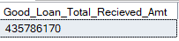
--Total Percentage of Bad Loan
SELECT
(COUNT (CASE WHEN loan_status = 'Charged Off' THEN id END)* 100)
/
COUNT(id) AS Bad_loan_percentage
FROM bank_loan_data
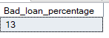
--Total Applications For Bad Loan
SELECT COUNT(id) AS Total_Bad_Loan_Application
FROM bank_loan_data
WHERE loan_status = 'Charged Off'
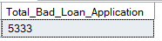
--Bad Loan Funded Amount
SELECT SUM(loan_amount) AS Total_Bad_Loan_Funded_Amount
FROM bank_loan_data
WHERE loan_status = 'Charged Off'
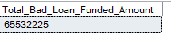

--Bad Loan Amount Recieved
SELECT SUM(total_payment) AS Total_Bad_Loan_Amount_Recieved
FROM bank_loan_data
WHERE loan_status = 'Charged Off'
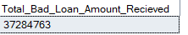
--Loan Status Grid View
SELECT
loan_status,
COUNT(id) AS Loan_Count,
SUM(total_payment) AS Total_Amount_Recieved,
SUM(loan_amount) AS Total_Funded_Amount,
AVG(int_rate * 100) AS Interest_Rate,
AVG(dti * 100) AS DTI
FROM bank_loan_data
GROUP BY loan_status
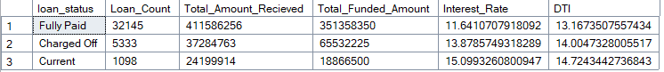
SELECT
loan_status,
SUM(total_payment) AS MTD_Total_Amount_Recieved,
SUM(loan_amount) AS MTD_Total_Funded_Amount
FROM bank_loan_data
WHERE MONTH(issue_date) = 12 AND YEAR(issue_date) = 2021
GROUP BY loan_status
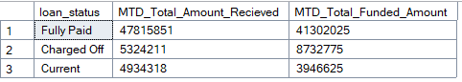
SELECT
loan_status,
SUM(total_payment) AS MTD_Total_Amount_Recieved,
SUM(loan_amount) AS MTD_Total_Funded_Amount
FROM bank_loan_data
WHERE MONTH(issue_date) = 12 AND YEAR(issue_date) = 2021
GROUP BY loan_status
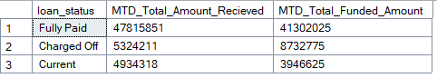

--Loan Grid View PMTD
SELECT
loan_status,
SUM(total_payment) AS PMTD_Total_Amount_Recieved,
SUM(loan_amount) AS PMTD_Total_Funded_Amount
FROM bank_loan_data
WHERE MONTH(issue_date) = 11 AND YEAR(issue_date) = 2021
GROUP BY loan_status
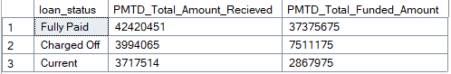
Dashboard Overview
SELECT
MONTH(issue_date) AS Month_Number ,
DATENAME(MONTH, issue_date) AS Month_Name,
COUNT(id) AS Total_Loan_Applications,
SUM(loan_amount) AS Total_Funded_Amount,
SUM(total_payment) AS Total_Amount_Received
FROM bank_loan_data
GROUP BY MONTH(issue_date), DATENAME(MONTH, issue_date)
ORDER BY MONTH(issue_date)
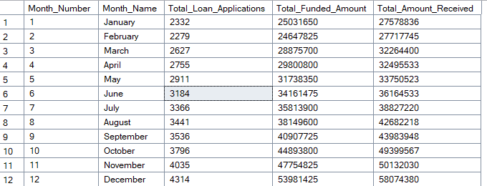

--Total Loan Applications by state
SELECT
address_state,
COUNT(id) AS Total_Loan_Applications,
SUM(loan_amount) AS Total_Funded_Amount,
SUM(total_payment) AS Total_Amount_Received
FROM bank_loan_data
GROUP BY address_state
ORDER BY SUM(loan_amount) DESC
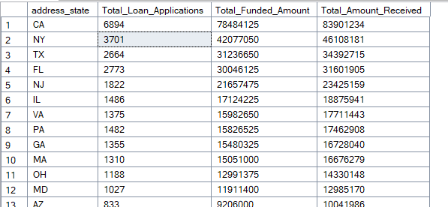
SELECT
term,
COUNT(id) AS Total_Loan_Applications,
SUM(loan_amount) AS Total_Funded_Amount,
SUM(total_payment) AS Total_Amount_Received
FROM bank_loan_data
GROUP BY term
ORDER BY term
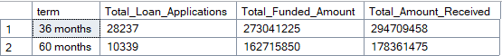
SELECT
emp_length,
COUNT(id) AS Total_Loan_Applications,
SUM(loan_amount) AS Total_Funded_Amount,
SUM(total_payment) AS Total_Amount_Received
FROM bank_loan_data
GROUP BY emp_length
ORDER BY emp_length

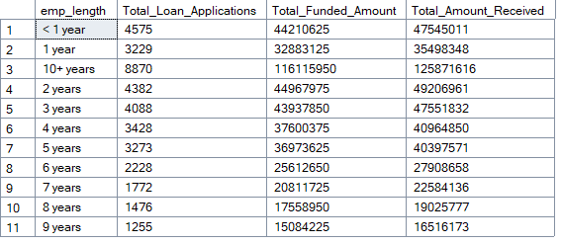
--Loan Purpose Breakdown
SELECT
purpose,
COUNT(id) AS Total_Loan_Applications,
SUM(loan_amount) AS Total_Funded_Amount,
SUM(total_payment) AS Total_Amount_Received
FROM bank_loan_data
GROUP BY purpose
ORDER BY COUNT(id) DESC
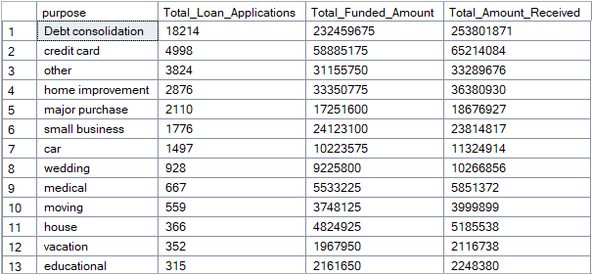
--Home ownership status
SELECT
home_ownership,
COUNT(id) AS Total_Loan_Applications,
SUM(loan_amount) AS Total_Funded_Amount,
SUM(total_payment) AS Total_Amount_Received
FROM bank_loan_data
GROUP BY home_ownership
ORDER BY COUNT(id) DESC
